**Day 6- CSS (Color, Backgrounds, Navigation Bar)**

https://lh6.googleusercontent.com/pzfkpYzj_xNKuCIRaMdGOcJRGHimowNa5u7Ned4rI9rrL8AGediPxVgoTzYM65B3F7T2wKnzzs4NN42aMrsGf_ZZvSDkx9V2RHZ5SJ6YjjldEA7E9x9SwUSXZmLWBKV9rfHuNRbkG3bXpFexSg

**Refresh yesterday’s Class-10 Minutes**

1. To select an element with a specific id, which character is used
2. &
3. $
4. #
5. @
6. What are the three ways to insert CSS in HTML documents?
7. Correct the HTML code

<html>

<head>

<link rel="stylesheet" type="text/css" href="mystyle.html">

</head>

<h1>This is a heading</h1>

<p>This is a paragraph.</p>

</body>

</html>

**CSS Colors & CSS Backgrounds-1 Hour**

**CSS COLOR**

**OUTPUT**

## RGB Color Examples

## Text-color set by using rgb(255, 0, 0)

## Text-color set by using rgb(0, 255, 0)

## Blue text-color

## Orange text-color

## Text-color set by using #FFFF00

## Text-color set by using #00FFFF

<!DOCTYPE html>

<html>

<body>

<h2>RGB Color Examples</h2>

<h2 style="color:rgb(255, 0, 0)">

Text-color set by using rgb(255, 0, 0)

</h2>

<h2 style="color:rgb(0, 255, 0)">

Text-color set by using rgb(0, 255, 0)

</h2>

<h2 style="color:blue;">

Blue text-color

</h2>

<h2 style="color:orange">

Orange text-color

</h2>

<h2 style="color:#FFFF00">

Text-color set by using #FFFF00

</h2>

<h2 style="color:#00FFFF">

Text-color set by using #00FFFF

</h2>

</body>

</html>

## CSS BACKGROUND COLOR

## OUTPUT

## HEX Color Examples

## Background-color set by using #FF0000

## Background-color set by using #00FF00

## Background-color set by using #0000FF

## Background-color set by using #FFA500

## Background-color set by using #FFFF00

## Background-color set by using #00FFFF

<!DOCTYPE html>

<html>

<body>

<h2>HEX Color Examples</h2>

<h2 style="background-color:#FF0000">

Background-color set by using #FF0000

</h2>

<h2 style="background-color:#00FF00">

Background-color set by using #00FF00

</h2>

<h2 style="background-color:#0000FF">

Background-color set by using #0000FF

</h2>

<h2 style="background-color:#FFA500">

Background-color set by using #FFA500

</h2>

<h2 style="background-color:#FFFF00">

Background-color set by using #FFFF00

</h2>

<h2 style="background-color:#00FFFF">

Background-color set by using #00FFFF

</h2>

</body>

</html>

## 

**CSS Background Image**

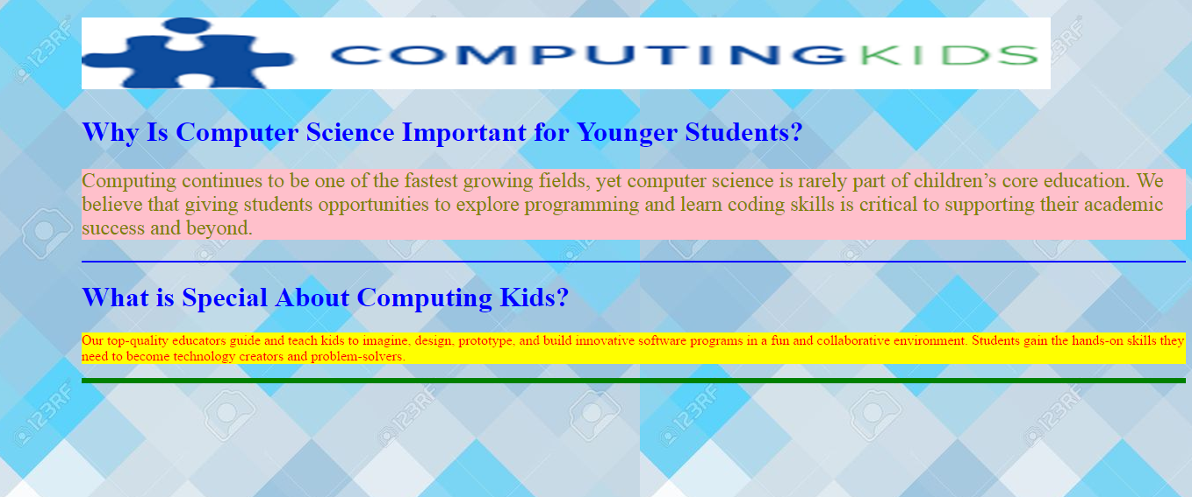

<!DOCTYPE html>

<html>

<head>

<style>

body {

background-image: url("bk.jpg");

margin-left:100px;

}

h1{

color:blue;

}

hr{

border: 1px solid blue;

}

#hr1{

border: 3px solid green;

}

</style>

</head>

<body>

<h1><img src="ComputingKids.png" alt="image" width="1104" height="82"></h1>

<h1>

Why Is Computer Science Important for Younger Students?

</h1>

<p style="color:olive; background-color:pink;font-size:x-large;">

Computing continues to be one of the fastest growing fields, yet computer science is rarely part of children’s core education.

We believe that giving students opportunities to explore programming and learn coding skills is critical to supporting their academic success and beyond.

</p>

<hr>

<h1>

What is Special About Computing Kids?

</h1>

<p style="color:red; background-color:yellow;">

Our top-quality educators guide and teach kids to imagine, design, prototype, and build innovative software programs in a fun and collaborative environment.

Students gain the hands-on skills they need to become technology creators and problem-solvers.

</p>

<hr id="hr1">

</body>

</html>

**Navigation Bar-1 Hour**

## Vertical Navigation Bar

[Home](https://www.w3schools.com/css/tryit.asp?filename=trycss_navbar_vertical#home)

[News](https://www.w3schools.com/css/tryit.asp?filename=trycss_navbar_vertical#news)

[Contact](https://www.w3schools.com/css/tryit.asp?filename=trycss_navbar_vertical#contact)

[About](https://www.w3schools.com/css/tryit.asp?filename=trycss_navbar_vertical#about)

A background color is added to the links to show the link area.

Notice that the whole link area is clickable, not just the text.

## CODE

<!DOCTYPE html>

<html>

<head>

<style>

ul {

list-style-type: none;

margin: 0;

padding: 0;

}

li a {

display: block;

width: 60px;

background-color: #f1f1f1;

}

</style>

</head>

<body>

<ul>

<li><a href="#home">Home</a></li>

<li><a href="#news">News</a></li>

<li><a href="#contact">Contact</a></li>

<li><a href="#about">About</a></li>

</ul>

<p>A background color is added to the links to show the link area.</p>

<p>Notice that the whole link area is clickable, not just the text.</p>

</body>

</html>

**Create a basic vertical navigation bar with a gray background color and change the background color of the links when the user moves the mouse over them?**

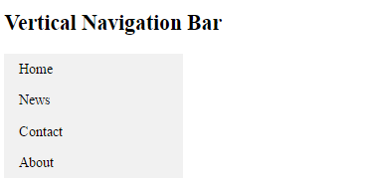

## CODE

<!DOCTYPE html>

<html>

<head>

<style>

ul {

list-style-type: none;

margin: 0;

padding: 0;

width: 200px;

background-color: #f1f1f1;

}

li a {

display: block;

color: #000;

padding: 8px 16px;

text-decoration: none;

}

/* Change the link color on hover */

li a:hover {

background-color: #555;

color: white;

}

</style>

</head>

<body>

<h2>Vertical Navigation Bar</h2>

<ul>

<li><a href="#home">Home</a></li>

<li><a href="#news">News</a></li>

<li><a href="#contact">Contact</a></li>

<li><a href="#about">About</a></li>

</ul>

</body>

</html>

## Horizontal Navigation Bar (Activity)-30 Minutes

### **Inline List Items**



**CODE**

<!DOCTYPE html>

<html>

<head>

<style>

ul {

list-style-type: none;

margin: 0;

padding: 0;

}

li {

display: inline;

}

</style>

</head>

<body>

<ul>

<li><a href="#home">Home</a></li>

<li><a href="#news">News</a></li>

<li><a href="#contact">Contact</a></li>

<li><a href="#about">About</a></li>

</ul>

</body>

</html>

### **Floating List Items**

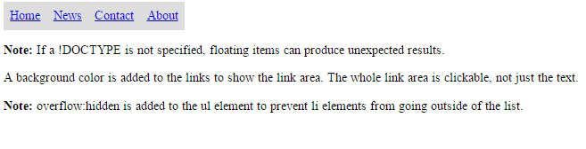

**CODE**

<!DOCTYPE html>

<html>

<head>

<style>

ul {

list-style-type: none;

margin: 0;

padding: 0;

overflow: hidden;

}

li {

float: left;

}

li a {

display: block;

padding: 8px;

background-color: #dddddd;

}

</style>

</head>

<body>

<ul>

<li><a href="#home">Home</a></li>

<li><a href="#news">News</a></li>

<li><a href="#contact">Contact</a></li>

<li><a href="#about">About</a></li>

</ul>

<p><b>Note:</b> If a !DOCTYPE is not specified, floating items can produce unexpected results.</p>

<p>A background color is added to the links to show the link area. The whole link area is clickable, not just the text.</p>

<p><b>Note:</b> overflow:hidden is added to the ul element to prevent li elements from going outside of the list.</p>

</body>

</html>

**Create a basic horizontal navigation bar with a dark background color and change the background color of the links when the user moves the mouse over them?**



**CODE**

<!DOCTYPE html>

<html>

<head>

<style>

ul {

list-style-type: none;

margin: 0;

padding: 0;

overflow: hidden;

background-color: #333;

}

li {

float: left;

}

li a {

display: block;

color: white;

text-align: center;

padding: 14px 16px;

text-decoration: none;

}

li a:hover:not(.active) {

background-color: #111;

}

.active {

background-color: #4CAF50;

}

</style>

</head>

<body>

<ul>

<li><a class="active" href="#home">Home</a></li>

<li><a href="#news">News</a></li>

<li><a href="#contact">Contact</a></li>

<li><a href="#about">About</a></li>

</ul>

</body>

</html>